**COLLEGE COMPANION APP**

Vignesh Raj T, Siddharath K , Vishnuprasad V

[**vishnuprasad45195@gmail.com**](mailto:vishnuprasad45195@gmail.com)[**vigneshraj2002@gmail.com**](mailto:vigneshraj2002@gmail.com)

[**siddhu7656@gmail.com**](mailto:siddhu7656@gmail.com)

**PANIMALAR ENGINEERING COLLEGE**

Bangalore Trunk road, Varadharajapuram, Nazarethpettai, Poonamallee,

Chennai, Tamil Nadu 600123

**Abstract:**

Nowadays, Educational mobile Apps directly target the psychology of the students which helps students to understand and grab the information from a different perspective. The aim of the app is to guide the students and keep them updated about what's happening in the class. Using mobile apps students learn from any geographical location but has also helped them use the technology at their disposal in judicious ways. Students can now dedicate more time to read up and understand their subjects better. In this app, the student can get the announcement regarding any examinations, holidays, etc. Also, the student can get the notes of their respective subjects.

Keywords: Android Studio, Firebase, Figma

**INTRODUCTION:**

In today’s world, mobile apps render a good platform for banking, education, reading etc. Designing and developing of new mobile apps for specific tasks would further make services more user friendly. Nowadays Mobile apps most widely used for education and reading. Mobile apps allow users to have easy, functional access to information, services that they need in real-time and are optimized for hands on interaction. This companion app is to guide the students and keep them updated about what's happening in the class. student can get the announcement regarding any examinations, holidays, etc. Students can receive notices about upcoming exam result, and other events. Also, the student can get the notes of their respective subjects. Also, the previous day absentees don't know what happened in the class or laboratory etc. Newly join students feel difficulty to find their way to their classes, laboratory etc., in their department block. It is like an instructor app for the students for viewing the layout of their department, downloading notes, seeing results etc.

Existing system:

With the increasing demands of physical and psychological well-being, and education-related applications. This is a new kind of app which update the students about each and every event happening inside the classroom and inside the college campus. This app is developed using Android Studios and Figma.

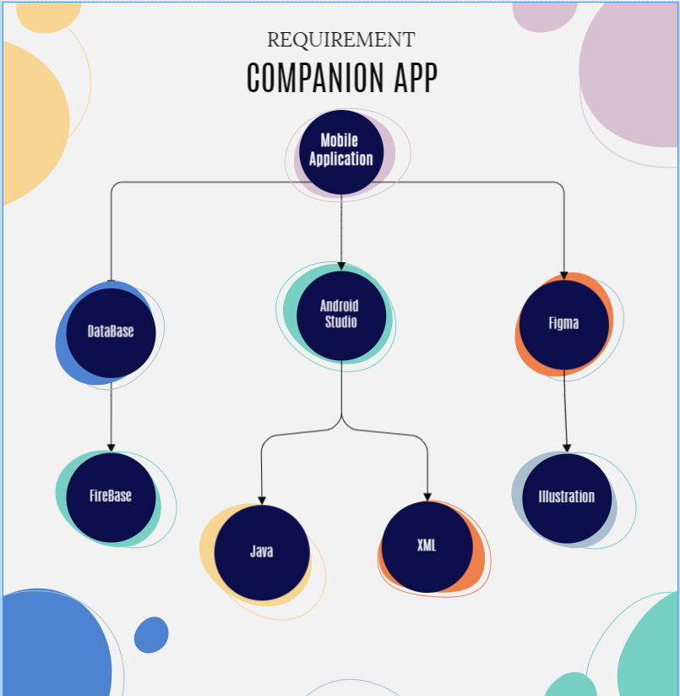

**Proposed Methodology:**

The main importance of this project is to guide newly join students in colleges with help of this app. This app has login page and signup page .With the login page students can login with their reg no and email id. Next, this app has an announcement to notify the students about the classroom updates and events happening inside the college campus. It also contains class notes of each subject for all year students. Students can see the exam results which are updated by the respective staffs through this app .We can view the IT block in a layout with help of this app and we can get the details about where the classes and labs etc.

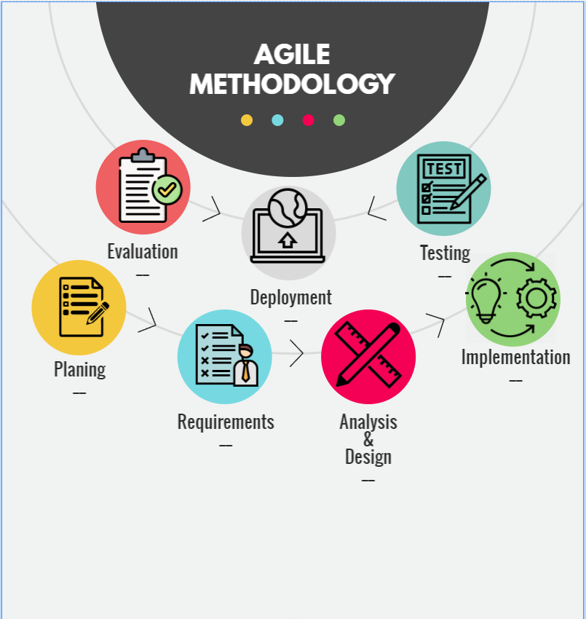

Methodology:

**Planning:**

Project planning plays an essential role as a helping guide for team members who are developing a project. we plan to design a mobile application for education purpose.

**Requirements:**

Requirements used in this project are android studio, firebase figma illustrator.

**Analysis and design:**

For designing, figma illustrator is used for the project. Figma illustrator is used only for designing purpose.

**Implementation:**

With the help of requirements and the design, implementation

Is done and app is developed.

**Evaluation:**

Evaluation is a systematic and objective assessment of an ongoing or complete project. In this project Evaluation is done

**Deployment:**

Deployment is a process of making the application work on a device. Therefore, Deployment is done output is developed

**Architecture Diagram:**

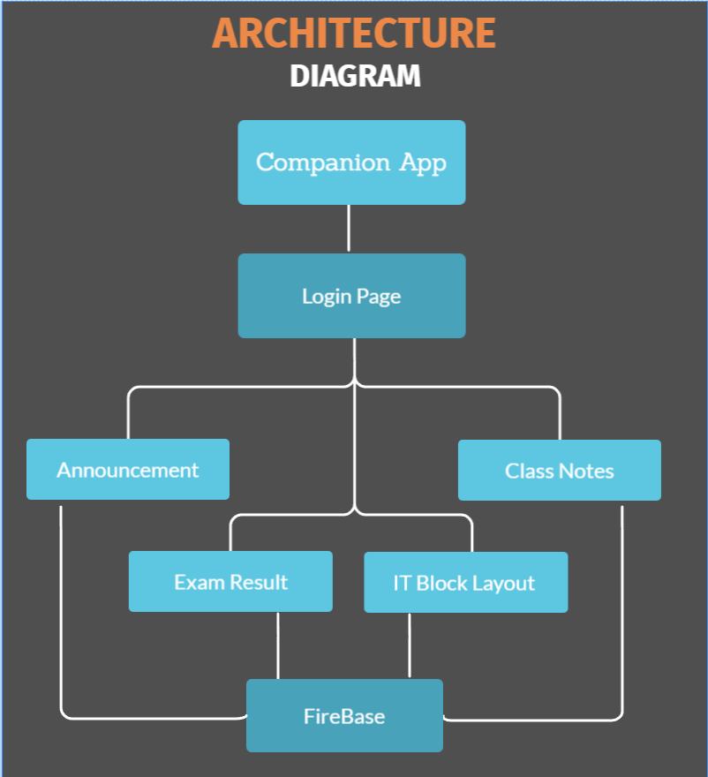

**Modules:**

**Android studio:**

For making a mobile application, android studio is mainly used for developing. It consists of java files, xml files and so one Using xml language, we can front end design a app. Using java language, we can function an app.

**Firebase database:**

firebase uses what is known as a NoSQL, database for storing data in a real time database. it lets for storing and sync data between the users in real time, we use this database for storing students’ details.

**Figma:**

It is an illustrator used for sketch and illustrator. We use this illustrator mainly for designing purpose.

**Implementation:**

We developed a mobile application for newly joined college students for getting announcement regarding their examination results, holidays etc. With help of this app they can download their notes and previous day absentees don’t what happen in the class, so there can get the information through this app. The main purpose of this app is to instruct the college students

**Conclusion:**

This companion app is designed to assist students and to keep them informed about what is going on in class. Students can receive notices about upcoming exams, result, holidays, and other events. Additionally, students can obtain their particular course notes. Also, absentees from the prior day can gain the details of class or in the laboratory notes. New admissions will have trouble navigating their department block to their classes, laboratories, and other facilities. It's similar to an instructor app for students to view the structure of their department, download notes, and see results, among other things.

**Result:**

An multi tasker functioned application, provides notification regarding college activities, storage of smart studies data materials is managed end of the day, directing navigation, a complete productive student friendly pocket android application.

**Reference**

[1] **“Professional Android 4 Application Development” by Reto Meier**

[2] **“Programming Android Java Programming for the New Generation of Mobile Devices” by Zigurd Mennieks**

[3] **“Hello, Android Introducing Google’s Mobile Development Platform” by Ed Burnette**

[4] **“Android Programming: Mastering Course for Beginners Quick Start to Develop Your Own App” by Mitchell Schuler**

[5] **“Android Programming in a Day! The Power Guide for Beginners In Android App Programming” by Sam Key**

[6] **“Head First Android Development: A Brain-Friendly Guide” by Dawn Griffiths and David Griffiths**

[7] **“The Definitive Guide to Firebase: Build Android Apps on Google's Mobile Platform” Moroney, Laurence**

[8]**“Build Mobile Apps with ionic 4 and firebase: Hybrid Mobile App Development” Cheng, Fu**